**4.2 Big-O Notation Worksheet**

1. Consider the following Edgy code, and decide which time complexity $\{(O(1)$, $O(logn)$, $O(n)$, $O\left(nlogn\right),$ $O\left(n^{2}\right),$ $O\left(n^{3}\right), O(2^{n})$ $,O(n!)\}$ would best fit each example giving reasons for your conclusion. Also, write down a 1 or 2 sentence description for each mystery block stating what it does (without executing the code).

**Example A: mystery2 block**

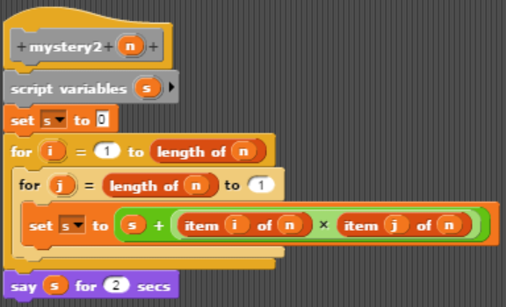

**O(N^2), nested for loop**

**Example B:**

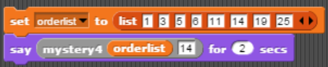

**O(1), same amt of tasks done regardless of input size**

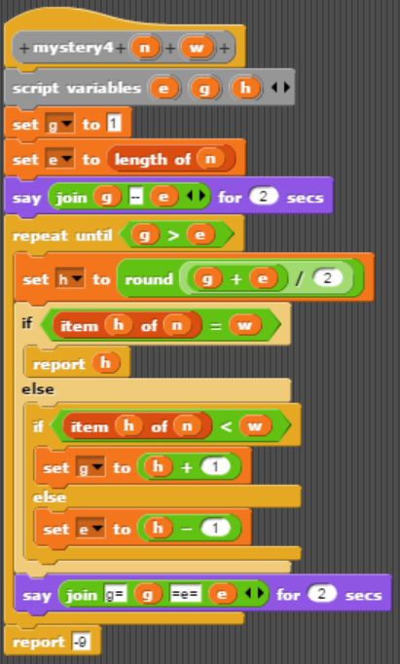

**binary search on the list n., in each iteration of the repeat loop, it halves the search range hence O(log n)**